MSU Sponsor Code: 018650
RFP Deadline: January 8, 2024
Project Date: July 1, 2024 – June 30, 2025
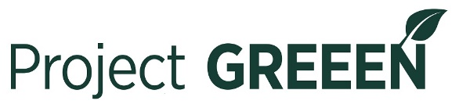

Cover Page 2024 (for new & continuing funding submission)

Proposal Title:
Principal Investigator:

Collaborators:
Campus Mailing Address:
Email Address:
Phone #:

EBS Proposal Development Number:
Umbrella Project/MICL #:
(MICL #’s are assigned to researchers with AgBioResearch appointments who create an umbrella project. If you do not have an ABR appointment just enter 12345.

Type of Project (check one) | Program Area (check one) | Money & Duration of Project
New Proposal ☐ | Applied Research ☐ | Total Duration of Project:
Resubmission from Previous Year(s) ☐ | Basic Research ☐ | New Proposal-Funding Requested Yr 1:  Continued Proposal-Funding Requested Yr 2:
2nd Yr Funding Request ☐ | Extension/Demonstration ☐ | Total Cost of Proposal:

Have you submitted or will you be submitting a similar proposal with a commodity group? Yes ☐ No ☐

Will the proposed project utilize MSU greenhouse space? Yes ☐ No ☐

Will this project be used as matching funds for a competitive grants program with a match requirement?
If so, what is the name of the proposal and the grant program to which it will be submitted? Yes ☐ No ☐

(Name of proposal and grant program) ___________________________________________________

Proposal summary on next page>>

Proposal Summary:

